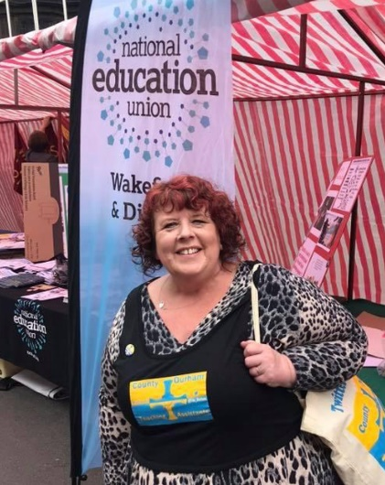
Nominate Trish Fay – County Durham TA for Support Staff Sector Seat

Patricia (Trish) Fay NEU no. N0720816
School rep at Bowburn Primary School Durham

After being a TA for 21 years in a School in Wakefield and TA Level 3 enhanced in a Local Authority school in Durham since 2008, my inner suffragette emerged in 2015 when I was told I would be sacked and re-employed under significantly worse conditions.
I became a proud member of the Durham Lions, a story that is known locally, nationally and globally. A true story of workers joining together and standing up for their rights.
The union I was a member of at the time, told me along with hundreds of other TAs, that there was nothing we could do about it so I left and joined ATL who were fighting for their members rights. My beliefs were being backed by a union who stood with me in protests, marched with me waving banners, spoke up for me when our employers wanted to silence my rights to speak out.
I was a leader in the dispute, heading up the Social Media campaign. Social Media was instrumental in gaining support for the Durham Lions and throughout it all, my union was beside me. I was encouraged to share our campaign and with growing confidence addressed meetings all over the country.
After amalgamation, the 88 ATL support staff members in Durham have grown to a determined group of over 600 NEU members. So many TAs saw the support and help we were getting and left the traditional unions to join the NEU who are a truly inclusive union.
Today I am proud to be a Rep in a county with one of the highest percentages of support staff reps in the Country. Our voices are heard in our meetings, WhatsApp groups and at union events across the Country with many Durham support staff taking on local and national roles and signing up for conferences, events, training and CPD.
I want to be on the National Executive because Support Staff are an integral part of our Union. I have experience of supporting our support staff members in my school where NEU membership amongst both TAs and Teachers has increased rapidly and I also offer support locally and regionally through a variety of social media platforms. I absolutely believe that the NEU’s offer to support staff is unique. We have a support Staff executive seat holder, we have a national Council, we engage our members at all levels, we champion inclusion and not segregation of our sectors. I absolutely believe that through engagement, continuing to offer high quality support and representing our members well our membership will grow and Durham is an example of that.

If elected I will:
- work with the members on all levels to continue to champion our diverse, skilled and invaluable members of support staff
- ensure that the thoughts, feelings and concerns of all Support Staff are heard across the union
- campaign for a pay rise for all Support Staff. We have been at the sharp end of Covid and deserve better
- organise for nationally agreed terms and conditions

I will continue to share the way NEU value their Support Staff members by providing excellent CPD, Support Staff conferences both regional and national and how each member has equal support from the NEU should they need it.

