ELECTION OF NEU NATIONAL EXECUTIVE 2021-23: REQUEST FOR NOMINATION
Dear Hazel
I hope you are safe and well in these unprecedented times.
I am writing to ask your district to put forward my nomination as a candidate in the forthcoming election for the NEU National Executive. Nominations close on March 8th and District nominations must be made at a quorate OGM.
As you will know I am currently a member of the Executive and also the District Secretary for Leeds NEU. I have a log track record of organising and winning for members, including:
- Numerous collective disputes which have successfully defended or improved our members jobs, pay and working conditions
- Negotiating best practice agreements which, eg, avoid compulsory redundancies ansd recognise the service of staff who move from academies to LA school
- Increasing NEU membership, rep density and workplace organisation to their highest ever levels.
As an Executive member, I believe I have represented members well, regularly reporting back to member meetings whenever possible and providing written reports of NEC meetings. Most of you will know that I have given detailed and clear reports to Regional Council and Regional Executive meetings.
As an Executive member I have, at every point, worked hard to ensure that the Union’s national campaigns were fought with determination and with strategies which could win. But I have also been prepared to be a critical voice. Where I have felt that we haven’t done enough I have said so clearly and loudly and organised at the grassroots of the Union to give a voice to others and to persuade the Union to take a different course. I believe that I have always done this in a way that respects the views, experience and contributions made by others.
My immediate priorities for the period ahead will be:
- Ensuring that the NEU is a union for all education staff. The creation and rapid growth of the NEU is one of the most exciting and positive developments in British trade unionism. I have always been a passionate advocate of one union for all school workers with equal rights to representation for support staff and teachers.
- Ensuring that the NEU is a democratic and member-led union. That means recognising that the districts and branches are the key representative bodies linking members to the Union and allowing them as much autonomy as possible from national micro-management
- A national contract for education staff and an industrial strategy which can empower members to win it
- A national campaign to ensure that the post-pandemic education system is not a return to ‘normal’- whether on the curriculum, assessment, workload or the treatment of supply teachers
I hope that you can support my nomination as a district and then recommend to your members that they vote for me in the election. I have enclosed a completed nomination form for your use
With thanks and in solidarity
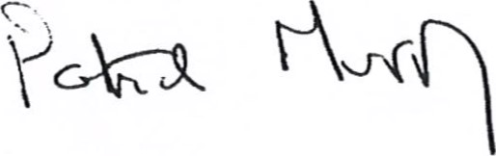
National Executive member, District 2
District and Branch Secretary, Leeds NEU
Patrick.murphy@neu.org.uk

