Dear District Secretary,

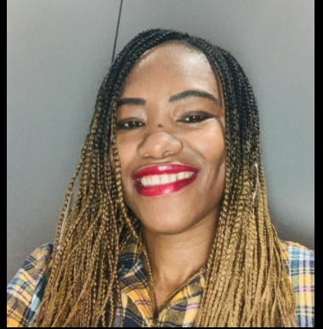

My name is Denise S. Henry, an experienced teacher for over 20 years and I am seeking your support to become the next Black Constituency Seat holder on the National Executive. I have been nominated by my district Lambeth NEU. I would welcome the opportunity to attend your next district meeting to talk to your members, listen and answer their questions but also share my vision for Black Members during and post-COVID.

I am the Equalities Officer and NEU school representative for Lambeth NEU and I have been a committee member for my district for the last 13 years. In 2018 I was elected as the first black woman to be a member of the LGBT+ National organising forum and in 2020 I became the first black woman to be elected as vice- chair for the forum as well, in its long history. I was also awarded an award for outstanding intersectionality work at the last Black Educators Conference in 2020. I have been nominated as NEU Black Educators Conference steering committee for many conferences and led workshops and co-chaired parts of the conferences. I have a strong track record of organising and representing Black members in our union at School, District, Regional and National level. I have been a Middle Leader in a Primary school for a number of years, and led on different subjects and equality areas, I have consistently been an active trade unionist. As the Network leader of the NEU Black LGBT+ network (which won the award for most inspiring intersectionality network in 2019 at the LGBT+ conference) and I am also the co- founder of the NEU South –East London network, I work effectively with NEU Black Organising Forum and many grassroots organisations. I continue to support fellow members, mobilise local, regional and national networks, in addition to representing the union at different black and lgbt+ events and TUC conferences. I have sought to inspire members to be more involved in the union and organised union different engagement events. I have regularly spoken at Annual Conference supporting Equalities motions and

If elected I would like to build on the foundations of some of our inspirational, innovative and pioneering black trade unionists like Baljeet Ghale, Roger King, Betty Joseph and our new Senior Vice President, Daniel Kebede.
Now more than at any other time in our history that black members need and demand a strong, committed voice within our executive, a strong voice to fight for the survival of Black Educators, as a self-organising section within our union, within education as a whole. For years we have battled against racism and discrimination in the workplace, we have battled for fair and positive recruitment and retention practices and progression into senior leadership position. We have also battled to protect our lives in our roles during this worldwide pandemic. As we all know the threat is real but we have also learnt that it is only through unity, mobilising our workforce and collective bargaining that we - the NEU- will be a real force to be reckoned with.

My motto - no Black members will be left behind! We have a wealth of experience and skills and I will help to inspire Black members to reach their full potential.

I would welcome the opportunity to attend your next district meeting to talk to members, listen and answer their questions but also to share my vision for Black Members going forward during and post-COVID.

I look forward to meeting your membership in the near future and I hope to gain their support.

Kind regards,

Denise

