ALLISON BARNES:
SEEKING RE-ELECTION TO THE NATIONAL EXECUTIVE COMMITTEE
I deem it an honour to serve the NEU and its members, at both local and national levels. Locally, I am a member of Kirklees District Committee and Yorkshire & Humber Regional Council, in addition to workplace representative at the University of Huddersfield. Nationally, I am one of the Executive Committee members for District 2 (South & West Yorkshire). I am a member of the Member Defence Strategy Committee and the Equalities Committee. I am also a member of the Health & Safety Organising Forum. I am the only member of the current Executive Committee representing initial teacher education and higher education.

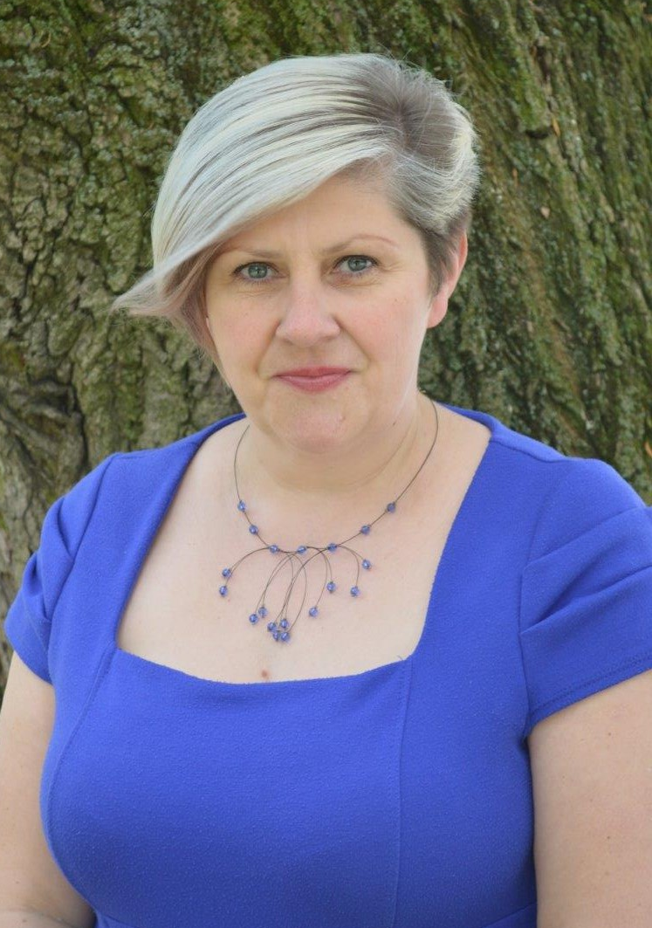

As a lecturer in ITE in higher education and previously as a secondary Science teacher in the maintained sector, in addition to being a committed trade unionist for over two decades, I have shared experience of the professional issues which affect us all. Working with young people should be a highly valued profession and I consider it paramount that we recruit and retain the best educationists through high quality initial training and adequately resourced continuing professional development. I campaign for a safe working environment, fair financial reward, an end to unnecessary workload and an entitlement to a life-work balance.

We have a moral duty to campaign with a strong, persuasive voice to provide the best possible education for the young people in our care. Through appropriate funding, senior leaders, governors, curriculum and pastoral managers, teachers, lecturers and classroom support staff can ensure that all young people have equality of opportunity to achieve their full potential. In the face of challenges to education, both locally and nationally, our best recourse is to advocate, calmly and responsibly, our enlightened professional values.

I feel strongly motivated to maintain and further develop the connections between the National Executive Committee, Regional Councils, District Committees and the members and am seeking re-election to the position of Executive member for the Executive District 2. I ask for your continued support to enable me to fulfil this aim.

Thank you.

